

CSCI7121: Industrial Training & Seminar - Report

Training Completed at Indian Statistical Institute, Hyderabad

Title of the project :

Guide : Dr. G S R Murthy

Student Details :
C. Nandita - 2023001442
Shazia - 2023003578
M. Sai Dheeraj -2023002482
K. Rithika - 2023002986

MSc. Data Science II Year
2024 -2025

TRAINING CERTIFICATES

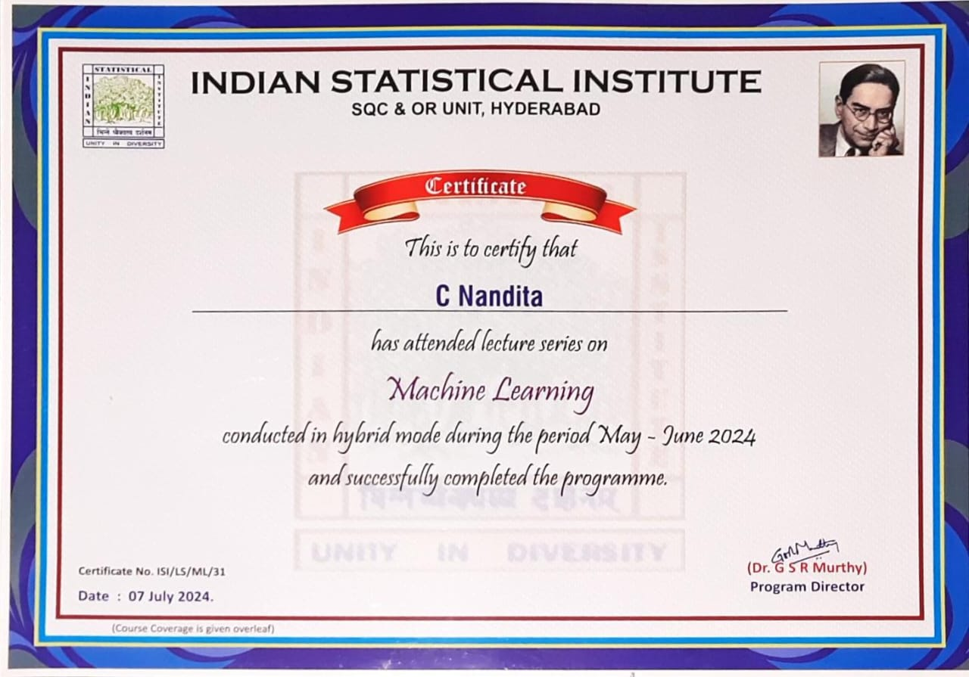

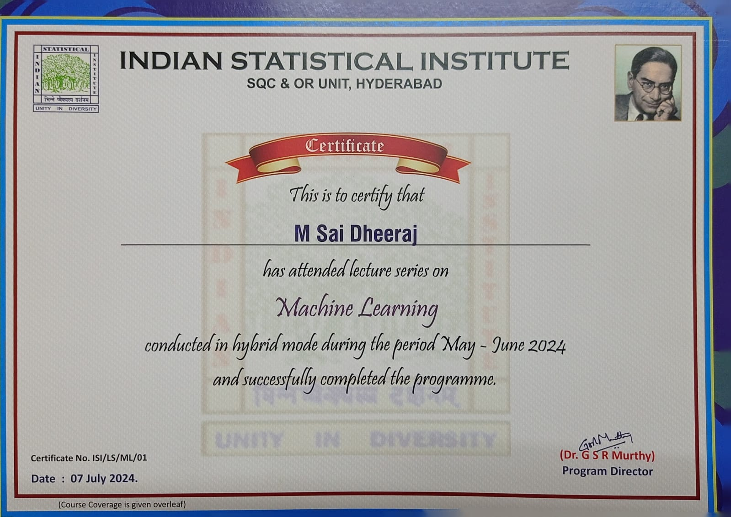

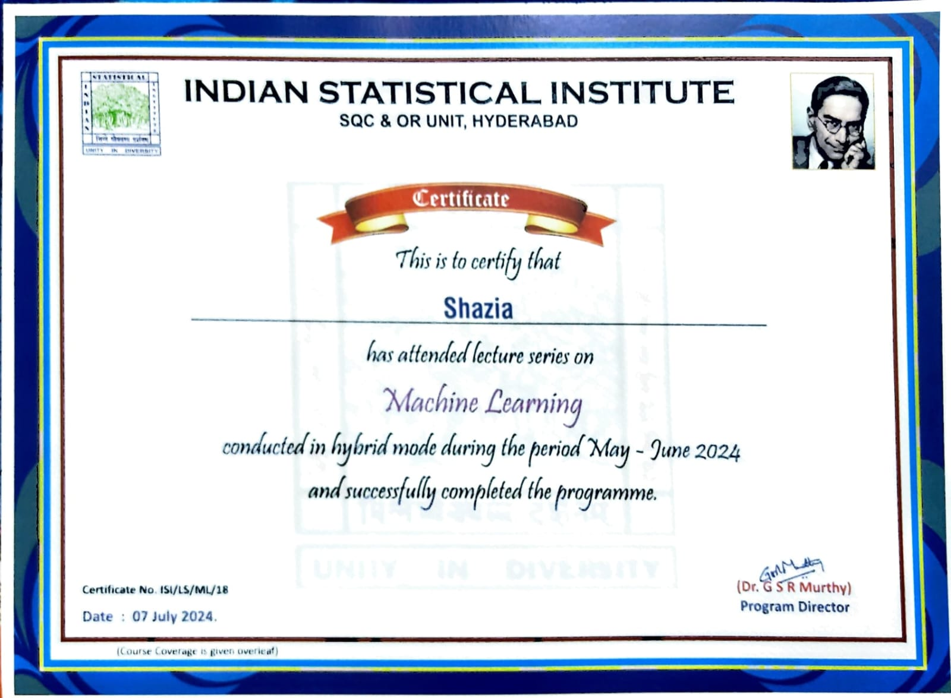

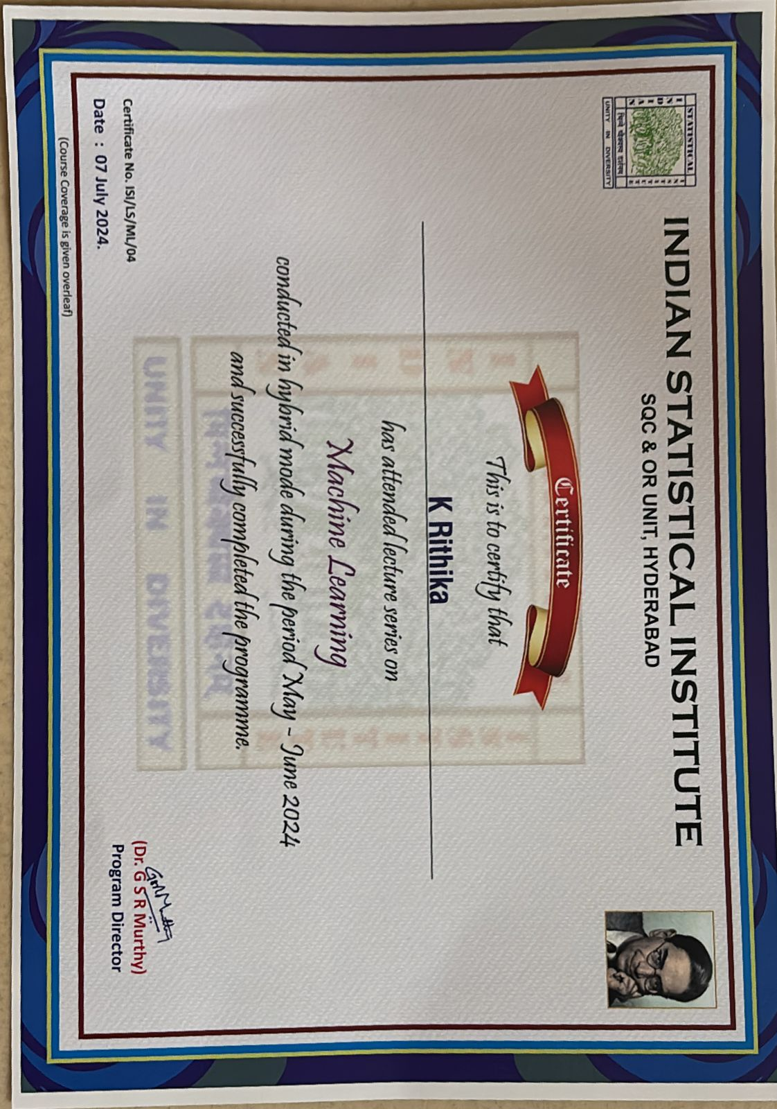

INDEX

- About the Organization — 6
- Project Schedule — 7
  - Timeline & Key Milestones
- Work Done — 8
  - Data Collection, Preprocessing, Analysis & Results
- Specific Assignment — 9
  - Introduction
- Problem Definition — 10
- Problem Statement
  - Key Challenges & Objectives
- Implementation — 12
  - Data Methods & Analysis
- Future Work — 19
  - Potential Improvements & Further Research
- Learnings After Training — 20
  - Key Insights & Lessons Learned
- Conclusion — 21
  - Summary & Final Recommendations

ABOUT THE ORGANIZATION



Indian Statistical Institute was founded by Late Prof P C Mahalanobis on 17 December 1931 in Presidency College, Kolkata.It was declared as an Institution of National Importance by an act of Parliament in 1959. ISI is Devoted to the research, teaching and application of statistics in various fields including industry. It has four centers located at Delhi, Bangalore, Chennai and Tezpur. Offices of the Institute, located in several other cities in India like Hyderabad, are primarily engaged in projects and consultancy in Statistical Quality Control and Operations Research.

PROJECT SCHEDULE

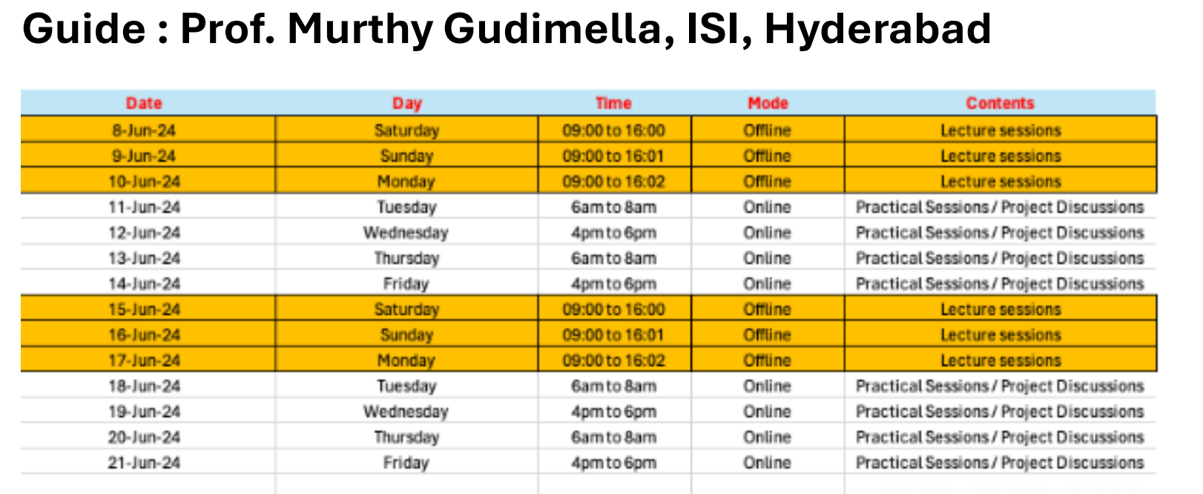

The sessions were conducted in hybrid mode during the month of June . We had a written assessment along with the final presentation on 7th July 2024. We also received our certificates on the same day.

WORK DONE

- Data Collection & Preprocessing:
  - Collected and cleaned restaurant data from five days for analysis.
- Feature Selection:
  - Identified key features (e.g., number of persons, reservations, bill amount) affecting revenue.
- Data Analysis:
  - Used linear regression to explore the relationship between variables and revenue.
  - Calculated R-squared values to evaluate model fit for each day.
- Insights & Observations:
  - Identified peak times, highest bills, and factors contributing to revenue variations.
  - Noted operational inefficiencies like waiting times and suggested improvements

SPECIFIC ASSIGNMENT

INTRODUCTION:

The restaurant industry thrives on customer satisfaction, efficient operations, and the ability to adapt to dynamic market conditions. With the rise of data-driven decision-making, businesses now have the opportunity to harness their data to gain insights that can significantly enhance their operations and boost revenue.

This project, titled “Data-Driven Revenue Optimization for a Restaurant,” focuses on analyzing operational data from a restaurant over a period of five days. The goal is to uncover key factors influencing revenue, such as customer demographics, reservation patterns, group sizes, peak dining times, and waiting times. By using statistical modeling, particularly linear regression, we aim to quantify the relationship between these variables and the restaurant’s revenue, providing actionable insights for improving profitability.

The analysis not only highlights when and why the restaurant generates the highest revenue but also identifies inefficiencies, such as long waiting times, which can impact customer experience. With this information, the restaurant can better allocate resources, plan promotions, and optimize its overall operations to cater to peak demand, thus driving higher customer satisfaction and increased profits.

This project serves as a practical demonstration of how data analytics can be leveraged in real-world scenarios to improve business outcomes and operational efficiency.

PROBLEM DEFINITION:

Problem Statement:
In order to provide practical insights that help spur revenue growth, the main focus of this project is to conduct a thorough study of restaurant data. To find trends that will provide the restaurant's decision-making process a data-driven basis, we will analyze the data based on different parameter and objectives.

Data Description:
The restaurant dataset consists of data from five days and contains both numerical and categorical variables.

Numerical Columns:
- Arrival time
- Clock arrival time
- Number of persons
- Number of children
- Time spent
- Bill
- Adults

Categorical Columns:
- Unreserved
- Reserved

OBJECTIVES:
The main objectives of the project include:
- Calculating waiting time.
- Analyzing the relationship between reserved tables and bill amounts.
- Investigating the relationship between the number of adults and children and the bill.
- Calculating maximum and average waiting time.
- Identifying the peak times when the number of customers is highest.
- Calculating the highest and average bills for each day.

IMPLEMENTATION

We implemented Linear Regression in our project to predict the dependent variable bill with the help of 8 Independent variables, to analyze which variable is influencing the bil the most in order to increase the restaurant revenue.

Linear Regression:
Linear Regression is a statistical method used to model the relationship between a dependent variable (target) and one or more independent variables (features). It predicts a continuous outcome by fitting a linear equation to the data. The equation for simple linear regression is:
y=β0+β1x+ϵ
Where:
- y is the predicted value.
- β0​ is the intercept.
- β1 is the coefficient (slope) for the independent variable x.
- ϵ is epsilon is the error term.

Data cleaning was performed to ensure consistency and reliability.
To Clean the Restaurant Dataset, we have used certain methods to clean the dataset they are
- Observing the Null values.
- Capping Method Handling Null Values.
We Observed that they are no outliers in dataset.

- ADDING WAITING COLUMN IN DATASET:

This code adds a Waiting_time column to the DataFrame with randomly generated values based on a normal distribution. It then ensures that all waiting times are non-negative by replacing negative values with 0. The result is a DataFrame where each row has a waiting time associated with it, ready for further analysis with a mean of 10 and a standard deviation of 2.5.

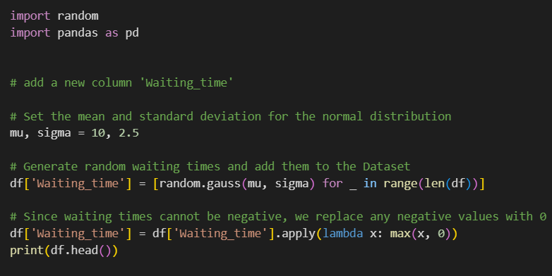

PERFORMANCE METRICS FOR LINEAR REGRESSION:
R-squared (R²) - Measures the proportion of variance in the dependent variable that is explained by the independent variables in the model.
Range: 0 to 1.
R² = 1: Perfect fit (model explains all the variability).
  - R² = 0: The model explains none of the variability.
Indicates the explanatory power of the model. Does not penalize for overfitting; adding more variables will always increase R², even if they are irrelevant

- RELATIONSHIP BETWEEN RESERVED +NUMBER OF PERSONS VS BILL:

Handles missing data either by dropping rows where Reserved is missing or imputing missing values with the most frequent value. Splits the dataset into training and testing sets. Trains a linear regression model to predict the bill amount (Bill) based on whether the reservation was made and the number of persons in the group.

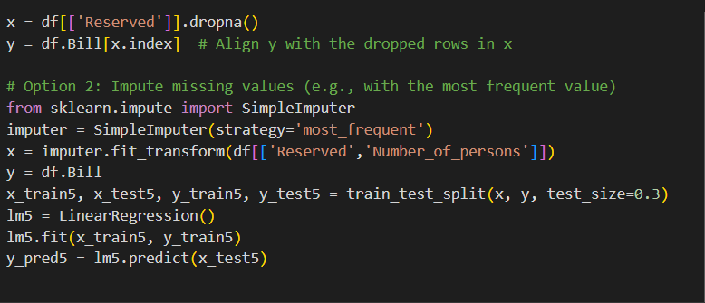
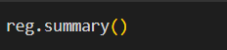

- RELATIONSHIP BETWEEN NUMBER OF ADULTS VS BILL:

The first part of the code performs a linear regression using sklearn to predict the bill amount (Bill) based on the number of adults (Adults).

The second part uses OLS regression from statsmodels to provide a more detailed statistical analysis of the relationship between Adults and Bill, including parameter

estimates and significance tests. The OLS approach is typically used for deeper insights and reporting in statistical models.

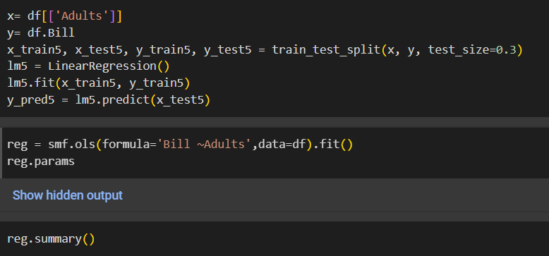

- RELATIONSHIP BETWEEN NUMBER OF CHILDREN VS BILL:

The first part of the code uses sklearn's Linear Regression to predict the bill based on the number of children in the group, splitting the data into training and testing sets.
The second part uses statsmodels' OLS regression to provide a more detailed statistical analysis of the relationship between the number of children and the bill amount, offering insights into model significance and other statistical properties.

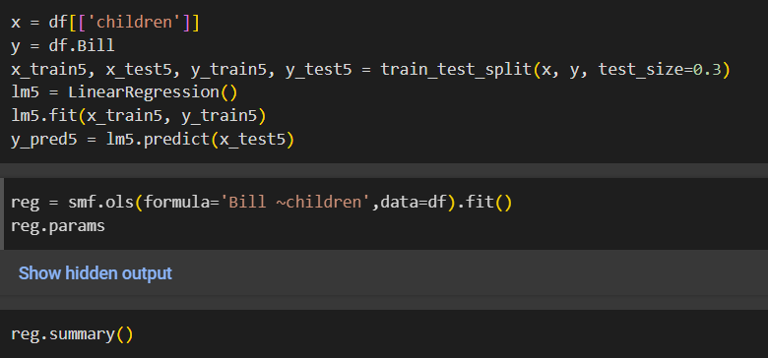

- CALCULATING MAXIMUM AND AVERAGE WAITING TIME

Waiting time is the time a customer waits before being served. This is calculated randomly using normal distribution. The maximum waiting time indicates the worst-case scenario, i.e., the longest any customer had to wait. This can be useful for identifying bottlenecks or inefficiencies in the system.
mean() gives you the average waiting time. max() gives you the maximum waiting time.
Both metrics help analyze customer service efficiency by providing insights into typical and extreme waiting durations.

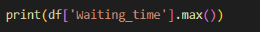
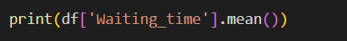

- CALCULATING PEAK TIME WHEN THERE ARE MAXIMUM NUMBER OF CUSTOMERS

The peak time refers to the time period when the highest number of customers are there in the restaurant. This is done by grouping the data by arrival time and summing up the number of people who arrived at each of those times.
Then, it identifies the time with the highest number of people arriving and prints that peak time along with the number of people at that moment.
This approach helps in identifying the peak hour or moment when the business (or system) had the highest traffic or load.

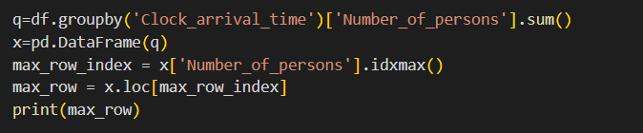

- CALCULATING HIGHEST BILL FOR EACH DAY

The code is selecting relevant columns (arrival time, bill, and number of persons) and then identifying the row with the highest bill amount.
It prints the details of this peak transaction, showing the time, bill, and how many people were involved in that transaction.

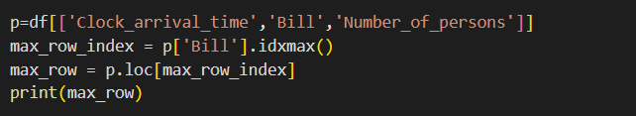
FUTURE WORK

In the future, further analysis could be performed to improve restaurant operations and customer satisfaction. Some possibilities include:
- Predictive modelling: Develop machine learning models to predict customer footfall on different days and at various times, helping optimize staffing and resource allocation.
- Dynamic pricing strategies: Use historical data to dynamically adjust prices during peak and non-peak hours to maximize revenue.
- Customer segmentation: Group customers based on their spending habits, reservation behavior, and group sizes to offer tailored promotions or discounts.
- Automation and efficiency improvements: Explore automation for table reservations, seating arrangements, and real-time waiting time estimates to enhance customer service during peak hours.

LEARNING AFTER TRAINING

From the analysis, several insights were gained:
- Relationship Insights: Strong relationships were observed between the number of customers, reservations, and bill amounts on certain days, especially on Day 4, which had the highest correlation.
- Peak Management: Days with higher waiting times and peak customer arrivals (like Day 5) indicate potential bottlenecks, offering learning opportunities for optimizing operations.
- Revenue Optimization: Day 3, with the highest average bill, suggests that targeting larger groups or promoting group discounts on such days could maximize revenue.

CONCLUSION/SUMMARY

The project aimed to analyze restaurant data to identify trends and optimize revenue. Key findings include:
- Day 4 had the strongest relationship between the number of persons, reservations, and bill amounts, suggesting operational or contextual factors that can be further explored to boost revenue.
- Day 3 showed the highest average bill, indicating that targeting larger groups or promoting offers on this day could increase profitability.
- Day 5 had the longest waiting times, highlighting the need for better operational management to improve customer satisfaction and reduce delays during peak times​

